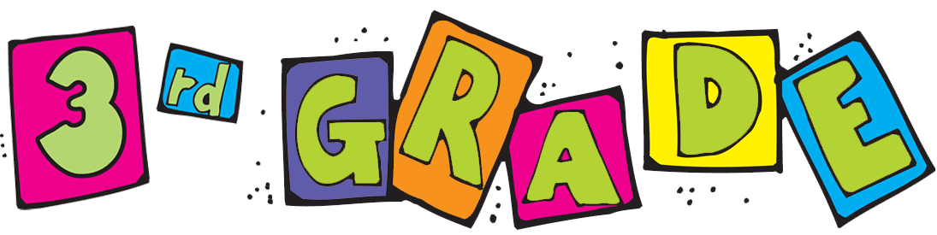

**2022-2023 Supply List**

Here is a list of supplies that your 3rd grader will need to bring along with them in September:

* 2 packs of No.2 pencils
* 2 packs of pink erasers
* 1 set of headphones (in a zip lock bag with student name)
* 1 pack of dry erase markers (expo brand)
* 1 pencil case
* 5 glue sticks
* 2 packs of post its
* 6 marble **composition** notebooks (no spirals)
* 1 pack of crayons (to be kept at home)
* 1 pair of scissors (to be kept at home)
* 1 book bag (no wheels)
* 1 pack of computer printing paper
* 2 boxes of tissues
* 2 bottle of hand sanitizer
* 2 pack of Lysol wipes
* 1 roll of paper towels



Hello Parents! We welcome you and your child to 3rd grade. Below you will find a list of expectations for this school year.

* Arrival: All students must arrive at school by 8:15 a.m.
* Uniform: Students must come dressed in their uniform daily
* Students must be prepared for school each day (i.e.: book bag packed with homework folder, 2 sharpened pencils, erasers, etc.).
* Homework: Homework will be assigned **every night** in all of their major course work areas. Please check your child’s homework folder and planner nightly to ensure that they are completing their assignments.
* Conduct: It is expected that students will follow all of the building and classroom rules.
* ELA: Students must read for at least 30 minutes every night for reading fluency. Students must also complete 60 minutes of iReady Reading weekly.
* Math: Students must study their multiplication math facts every night for math fluency. They must also visit iReady for 10 minutes nightly.
* Science: Students must complete 45 minutes of Readorium weekly.
* All students must to come to school ready and prepared for a fun day of learning!

If you have any questions or need to reach out to us, please feel free to stop in during, before, or after school hours. We’re excited to be working with you this year!

Your 3rd Grade Team,

Ms. Assia (ELA) Ms. Miller (ELA)

Ms. Napolitano (Math) Ms. Tynes (Math)

Mr. St. Fort (Social Studies) Ms. Devose (Science)

Mrs. Leon (Bilingual) Mrs. Dasgupta (SPED)

Ms. Gupta (ESL)